

UNITED STATES INTERNATIONAL UNIVERSITY -AFRICA
SCHOOL OF SCIENCE AND TECHNOLOGY

ONLINE PUBLIC TRANSPORT COURIER SERVICE SYSTEM

¹ YUSSUF SEIFUDIN, ² FARAH AHMED, ³ COLLINS ODUOR ONDIEK,
¹ Yussuf Seifudin, Student, Department of Computing, United States International University-Africa, Nairobi, Kenya

² Farah Ahmed, Student, Department of Computing, United States International University-Africa, Nairobi, Kenya

³ Assistant Professor, School of Science and Technology, United States International University-Africa, Nairobi, Kenya

E-mail: yseifudin@usiu.ac.ke, aifarah@usiu.ac.ke, coduor@usiu.ac.ke

Abstract
The Online Public Transport Courier Service System is a web-based system that is designed primarily for use in the courier service industry, especially within the transportation system in Kenya. This system will allow courier services companies to increase the scope of their business by reducing the paperwork cost and accountability of goods involved in this system also allows quick and easy management of transporting parcels from one point to another as they can be easily tracked compared to the use of manual systems of recording information as it includes being able to track the status of the parcel that was sent from the receiver and the sender.
After the parcel being sent has been processed a sent is sent with an estimated time of delivery and the customers will be updated once there is a delay moreover a notification will be issued to the customers for pick up however if the receiver is a distance away, they can also request a delivery thereafter the customer dashboard is updated that the meal is sent out and the estimated time of delivery once the parcel arrives at the destination then the dashboard is updated to be delivered. Since this will reduce the man required at the front desk it will reduce the loss of goods and services and accountability in terms of credit. This project is developed using PHP, JavaScript, and MYSQL. This system is an online application that can be hosted online and therefore the user needs an internet connection or the company’s local area network

1.0 Introduction
1.1 Background of the Study
With the growth of the internet, it has made it easier for customers and sellers to interact with each other daily in which the interaction has even grown on a global scale where someone living here in Kenya can buy items that can be found in another country. As this trend continues, courier companies need to adapt and grow in retrospect to other developed countries such as Germany, China, and Japan. This can also prove useful in developing countries such as Kenya and South Africa.
In Germany despite society’s increased shift to digital communications, the courier and parcel services industry has greatly developed positively over the past 5 years. This was greatly facilitated by the booming online trading platforms, which also translates that more and more parcels are being sent in a single shipment or express shipments. Especially during the years 2020 and 2021 which has greatly contributed both positive and negative aspects of it leading to the closure of some businesses during lockdowns many consumers would purchase a wide variety of goods and the courier industry would largely benefit from it.
Most goods that are imported and exported originate from China where there is a rapid rise in e-commerce and its surge has led to the rapid growth of the express delivery industry. With that, the volume of China’s express delivery business has greatly increased from 31.3 billion in 2016 to 83.4 billion in 2020.
Despite online shopping for product sales being inextricably linked to home delivery, online shopping for product sales grew by 21.7% in 2020, while parcel delivery (trucks) grew by 11.5%. According to an announcement by the Ministry of Land, Infrastructure, Transport, and Tourism of Japan, the number of parcel delivery services (trucks) handled in the Financial Year 2020 was 4.78 billion, an increase of 494.31 million over the previous year.
E-commerce is one of the primary drivers of the Japanese CEP market's expansion. Due to increasing internet user penetration, the e-commerce industry's revenue is expected to reach USD 128 billion by 2024. The domestic CEP market is likely to witness growth and hold the major share during the forecast period in line with the B2C e-commerce boom.
Within South Africa, although the courier, express, and parcel services sector faces weak economic conditions it still gets benefits from the growth in e-commerce sales, increasing demand for just-in-time deliveries, and also from the poor services being provided by the post office. With the increasing customer demand for speedy and flexible deliveries and the growth of disruptive startups and innovative delivery options are forcing traditional operators to review their distribution strategies and in some cases partner with or invest in new disruptive on-demand delivery companies to provide innovative and alternative delivery options.
For a long time in Kenya, B2B business transactions have been the major drivers of this sector. Therefore, the pricing model of having blanket rates for deliveries based on zoning was used across the grid and commonly accepted. Also, there was not too much pressure on delivery time, with most players having a next-day delivery or 24-hour timeline.
However, with the advent of the increasing mobile & internet penetration coupled with Kenya’s high upsurge of mobile payments, online consumer spending has now become the second driver of this sector. This trend both locally & internationally coupled with newer delivery models is proving to be very disruptive.
The Nigerian freight and logistics market has been on a slow growth trend for the past many years but is expected to grow at a compound annual growth rate (CAGR) of around four percent (4%) in the coming years. Over the past few years, Nigeria has experienced a slowdown due to poor infrastructure and logistical issues along with delayed customs procedures and congestion on the roads.
As a result, the country was ranked one hundred and forty-five (145) out of one hundred and ninety (190) economies in 2018 in the ease of doing business index and ranks one hundred and twelve (112) in the logistics performance index (2018). The current growth in Nigeria’s logistics Market has been due to the infrastructural developments in Railways and Airways, improvement in foreign ties with other countries, development manufacturing and export sector, and the rising e-commerce sector.

1.2 Problem statement
Lack of Customer Support – It is necessary to have a system that can handle orders from multiple e-commerce businesses and startup businesses.
Manual record keeping – the courier system will eliminate the need for human dependency in terms of keeping records about parcels or cargo.
Lack of parcel tracking – with the current parcel or courier systems in place a customer does not know if the parcel has reached its destination.

1.3 Objectives of the study
1.3.1 Overall goal
To design and develop an online system that enables parcels have been delivered on time ensuring there is customer satisfaction.

1.3.2 Specific Research Objectives
1.4 Research Questions
- What are the traditional challenges with existing courier services?
- What are the benefits of the Online Public Transport Courier system?
1.5 Scope of the study
Online Public Transport Courier System is a web-based application. To automate parceling systems in different areas of parcel and cargo transportation. The stakeholders will be the Global Post Office and the Public Transportation sector within the country.

1.6 Significance of the study
- This paper is relevant to Sustainable Development Goal (SDG) 2, specifically, to
- “Substantially end hunger and achieve food security within the country and improve nutrition and promote sustainable agriculture”
- This can be achieved through a generous donation to areas that are heavily affected by famine, and refugees.

2.0 Literature Review (1-2pages)
2.1 Introduction
The rise of the internet has enabled customers to be able to connect with businesses with ease, and this has led to the steady growth of package delivery around the world to the customer’s doorstep.

2.2 Literature review based on the specific research objectives
2.2.1 challenges of the physical courier system
Inability to manage multiple customers – many e-commerce companies are the main customers for a courier service provider. With this many customers, the courier service provider might be overwhelmed especially within developing countries.
Delayed deliveries – With many courier service providers within the country especially the Postal Corporation of Kenya, many of their customers have faced delays on their parcels and are forced to go to the main office. This has led to much customer dissatisfaction. This can also make the courier service provider lose its clientele and in turn also increase the overall shipping costs hence leading to a high rate of Return to Origin (RTO).
Poor visibility in the courier operations – With a lack of proper visibility would bring about poor customer experience, inaccurate KPIs to growing transportation risks, and a lack of real-time visibility into transportation activities within the courier system.
Human Dependency – Within the courier service in Kenya especially the Postal Corporation of Kenya, they highly depend on the human resource aspect of it such as they would manually writing down the parcel details, receiver and sender details, and many more. This can be proven to be hectic and the manually written records can lead to a long queue to within the offices.
High delivery cost – Some courier service providers have a high cost in managing operations such as order segregation, and selecting the right delivery vehicle. Assigning drivers, and planning the delivery routes. This may, in turn, require a considerable amount of time and effort to perform different operations will all in mind it might end up becoming expensive to transport the given parcel or the parcel transportation fee becomes high.
Lack of customer updates – With the current systems in place most of them do not have the means to keep both the e-commerce company and the end customer updated status of the courier is needed to keep the transparency within the service.

2.2.2 Benefits of the Online Public Transport Courier Service System
Courier status checks – With the new system customers can check and see where their parcels or shipment have reached. This will increase both customer satisfaction for the end user and the consignment or the e-commerce company.
Low-Cost Delivery – With the new system within the country this will ease the burden of cost in terms of the delivery this is where you only pay for the actual weight of the parcel to be transported from the sender to the receiver.
Resource automation –an online public transport courier system will limit the number of human resources in terms of relying on humans to manually write down the consignment details, from the sender and to the receiver details.
Tracking feature – with the new system users can check the consignment status by keying in the tracking number from the comfort of their own home. This will also ensure that the courier service provider will gain customer satisfaction with both the e-commerce company and the end customer.
Fast delivery option – the proposed system will ensure the consignment that will be received from the e-commerce company has reached its final destination and that is its end user, even in the remote part of the country. This will return increase customer satisfaction on both sides and reduce the Return to Origin (RTO).
Secure and Safe parcel delivery – the new system will ensure that consignment will be secured so that there is minimal chance of it arriving at its destination damaged or not arriving at all. Which can have a tracking feature where you can locate your package and know when it is delivered.
Adaptability to loads that exceed the size or weight – the proposed system has the flexibility that a postal service cannot offer such as the size or weight doesn’t matter. An example is the postal corporation of Kenya does not permit to send of parcels that are heavier than 30kg or with a combined length and depth of 1.5 meters.
2.3 Conclusion
This project aims to design an Online Public Transport Courier System that serves as a convenient way of sending parcels with a wider range of options than the traditional courier service. The users can be assured that their parcels reach them in time, and safely from any damages during transportation or from it being missing or stolen during transportation. This system will enable users to donate as well helping those unable to afford quality food access, clothes, and healthcare such as medicines and among others to gain access to them easily.
3.0 Research Design and Methodology (2-3 pages)
3.1 Locality of the project and Beneficiaries to the project
The system will be implemented within Kenyan boundaries starting with implementation in Nairobi, besides it can be improved and be used by other public transportation sectors in different counties and countries to improve courier services worldwide. The system stakeholder-who are the beneficiaries of this system including public transportation and the customers and e-commerce companies.

3.2 Research approach
3.2 Population of the study(Target group) and Sampling method
According to Plos one research, the courier and parcel service has increased its growth rate during the pandemic generating significant revenues. Where physical distancing, business lockdowns, and other business confinements that were placed have accelerated the growing trends in e-commerce. Internet users turned to online shopping more frequently and ordered more essential goods.
The situation resulted in the rise of business-to-consumer (B2C) sales and affected business-to-business (B2B) e-commerce. By the end of May 2020, online orders doubled year-on-year in North America and increased by 50% in Europe. Before the pandemic, the value of the global courier market reached EUR 330.3 billion in 2019, and according to forecasts, it will reach EUR 400 billion by 2024, which means an increase of 8–10% annually in subsequent years.

3.3 Data collection methods and Primary Data collection methods
3.3.1 Primary Data collection method
These methods involve data that is collected for the first time. For the proposed system, interviews and observation methods were done. The main primary data collection for this project is online questionnaires. The online questionnaire will consist of both open-ended and closed-ended questions. With the use of google forms, I will send this online questionnaire to the target group and then later collect, gather, and analyze the data through graphs.

3.3.2 Secondary Data collection method
The use of the internet to collect data
These methods consist of data that has already been collected by someone else and passed through a statistical process. The main source of secondary data for this project is the internet. In addition, other sources of information such as books, and journals will be used as references to gather adequate information.

3.4 Data analysis methods
Both qualitative and quantitative data analysis will be used for this project. In terms of any quantitative analysis, any numerical data will be analyzed with the use of graphs and pie charts. While the qualitative analysis the data will be represented through pictures that will explore the data more visually.

4.0 Research findings and analysis
4.1 Response rate
The response rate is determined by dividing the number of people who completed the questionnaire by the number of people in the study sample. In this research study, online questionnaires were administered to 50 participants. This response rate was satisfactory with an 80% response rate due to the limitations of time.

4.2 Demographics results
4.2.1 Distribution by Age
The responses were majorly distributed among the young persons. Majority of the respondents were between 18 - 25 years (88.2%), 26 – 35 years (11.8%), 36 – 45 years (0%) and over 35 years (0%). This shows that individuals from different age groups are interested in the idea of having an Online Public Transport Courier System. The age distribution is a clear indication that the participants have a good understanding of the project topic.
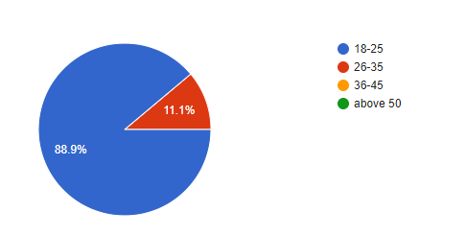
4.2.2 Distribution by Gender
The study’s results indicated that 47.1% of the respondents in the survey were female whereas 52.9% male. This indicates an almost even distribution of participants along gender lines, which is an important factor to consider for validating the responses. The pie chart below depicts the gender distribution of the respondents.
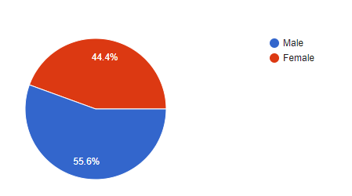
4.2.3 Distribution by courier service booking consignment distribution
The survey revealed that 58.8% of the respondents normally book by phone to send or receive a consignment from the courier services. While 41.2% of the respondents have to go physically to the courier service company in order to book the consignment transportation.
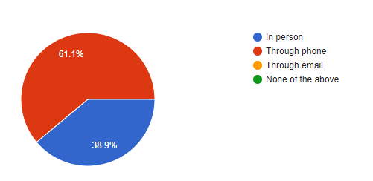
4.2.4 Consignment packing and Transportation conditions
The survey revealed that 66.7% of the respondents a lot of the consignment transportation should be taken can of in terms of securing it against damage and theft. While 33.3% of the respondents are satisfied with it being well secured and also as long as the consignment is transported to them.
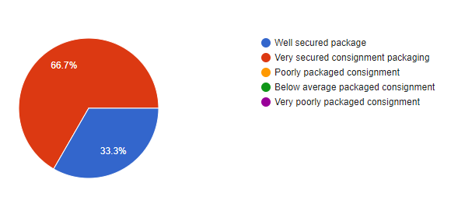
4.3 Challenges of a physical courier system in place
The survey has revealed that 50% of the respondents are dissatisfied with the current courier system in place in terms of consignment transportations are expensive in terms of its size and weight and also 50% of the respondents have also faced with consignment damages and theft during transportation which they are dissatisfied with. While 50% of the respondents are also dissatisfied with the long queues for booking courier transportation and 44.4% of the respondents are also dissatisfied with the current system in place which lacks a proper way for customers updates in terms of consignment tracking respectively.
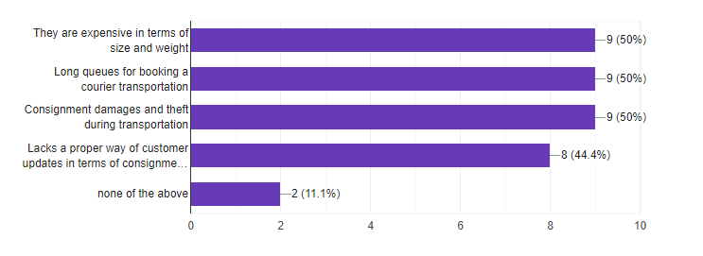

4.4 Distribution by the benefits of an Online Public Transport Courier System
83.3% of the respondents believe that a courier service company should be fast in delivering a consignment to its customer. While 55.6% of the respondents show that they care in terms of affordability for sending or receiving a consignment to its customer leading to customer satisfaction. On the Other 66.7% of the respondents are keen on the affordability cost of the consignment delivery that comes with the new system Online Public Transport Courier System.

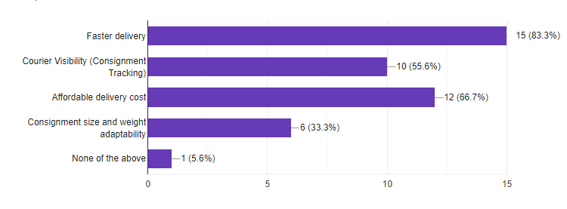
5.0 Discussion conclusion and recommendations (1 page)
5.1 Discussion
From the survey, we can conclude that the biggest challenge of the online courier service is that people might not have access to the internet as this service requires you to create an account and use the account to send their parcels to wherever they are sending them.
The ones that are most anticipated are the ease of sending parcels from wherever you are to wherever you want and it is trackable by the customer. A significant percentage replied that their main benefit from this proposed system would be the ability to parcel stuff from anywhere which is an important objective of this system.

5.2 Conclusion
The study concludes that Online Public Transport Courier System has changed the value chain. It is eminent that this system provides a safe, secure, and verified platform for all parties which help to bridge the communication gap and provide legitimate services. They are convenient, private, range of choices and time efficient. Most respondents that filled the questionnaire sent parcels by going physically to the company (58.8%) while (41.2%) used telephone to book for a courier service rather than the parcel system online which is 0%. Thus, creating an Online Public Transport Courier System would help in Courier services for all parties involved.

5.3 Recommedations
Online Public Transport Courier System will help workers in keeping accurate and up-to-date records of customers and their parcels wise reports, billing information and order management. We are expecting all Online Public Transport Courier System to have systems in place to carry out appropriate identity checks. During a risk assessment the courier owner would gather evidence about the risks for each individual service and the information that they provide at a distance, including on the internet, before providing that service.

5.4 Furture work
The current proposed system is targeted at the stakeholders in Nairobi County. Future work would be focused on broadening the system's breadth and catering to other stakeholders in numerous countries, or ambitiously the entire country.

6.0 References
APA Format
AUTHORS
Authors | Yussuf Seifudin, Student,  Farah Ahmed, Student,  Department of Computing,  United States International University-Africa, Nairobi, Kenya  E-mail:yseifudin@usiu.ac.ke, aifarah@usiu.ac.ke,  Website: http://www.usiu.ac.ke
Co- Author | DR.COLLINS ODUOR ONDIEK - Supervisor 1  Assistant Professor,  School of Science and Technology,  United States International University-Africa, Nairobi, Kenya  E-mail: coduor@usiu.ac.ke  Website: http://www.usiu.ac.ke

